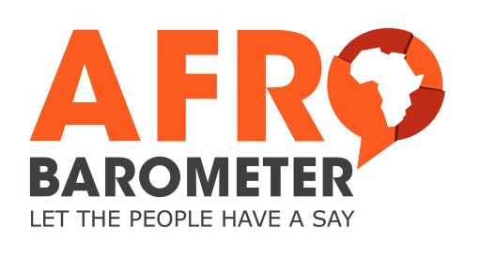
APPLICATION FOR EARLY ACCESS AND/OR RESTRICTED DATA
Please email your signed application to Afrobarometer Data Manager Carmen Alpin at c.alpin@uct.ac.za.
Personal details
Name:
Nationality:
Institution or Affiliation:
E-mail address:
Name of supervisor (PhD students):
Purpose of your research
Please provide a short summary of your project, indicating your research questions, hypotheses, and intended contribution

Datasets and variables required
Please specify round, country, and variables of interest

I agree:
- to preserve the confidentiality of, and not attempt to identify, individuals in the data;
- to ensure that the data are kept secure and not disclosed to anyone else until the data set is publicly released;
- to offer any prospective publication that makes significant use of our data first to the Afrobarometer Working Paper series (which does not preclude later publication of a revised version elsewhere);
- to acknowledge Afrobarometer as the source of the data in all publications resulting from its use by means of bibliographic citation in this form:
Afrobarometer Data, [Country(ies)], [Round(s)], [Year(s)],available at http://www.afrobarometer.org
- to acknowledge AidData as the source of the geocodes in all publications resulting from its use by means of bibliographic citation in this form:
BenYishay, A., Rotberg, R., Wells, J., Lv, Z., Goodman, S., Kovacevic, L., Runfola, D. 2017. Geocoding Afrobarometer Rounds 1-6: Methodology & Data Quality. AidData. Available online at http://docs.aiddata.org/ad4/pdfs/geocodingafrobarometer.pdf
- to send us bibliographic details of any published work based on our data;
- to try, where possible, to do the analysis and writing collaboratively with a member of the Afrobarometer Network, preferably an African member;
- to share with Afrobarometer any data produced by adding additional data to our datasets for Afrobarometer internal purposes;
- not to use the data for commercial purposes;
- that personal data about you may be held for validation and statistical purposes;
- to notify us of any errors discovered in the data.

Signature:............................................... Date:........................

